Chapter 2, Problem 56.

Determine V in the circuit of Fig. 2.120.
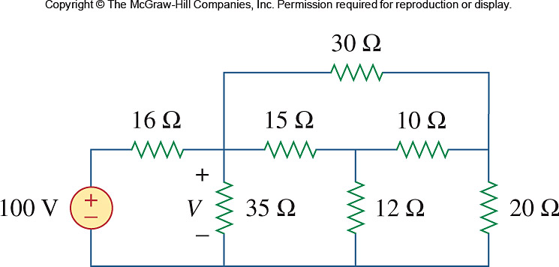

Figure 2.120
For Prob. 2.56.

